STM32CUBEMX HAL

This is a software with an intuitive and user friendly interface to configure the controller with appropriate clock frequency and also configure the peripherals. The end product is a project with header files and source files. The project file is available for a number of IDEs. Here we generate a project file for Keil MDK v5.

The first step to STM32CUBEMX is to select the right controller with the right number of pins

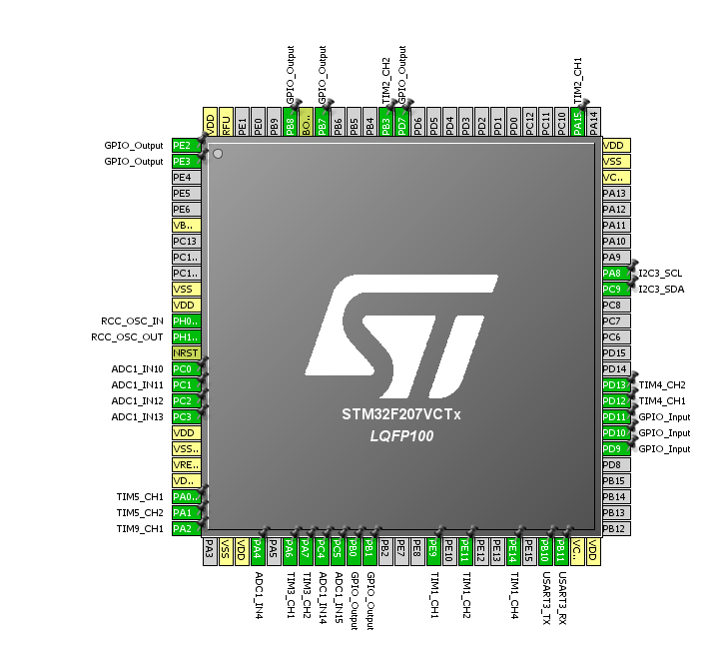

Pinout:

The second step is to assign pins and add peripherals to the project. There are a few ways to assign peripherals.

From the left hand window having the names of peripherals choose the peripheral and its mode. The pins shown above (green color) get assigned automatically.

For functions like setting a GPIO as input, output or external interrupt, it can be done by clicking on the pins and selecting the function.

Clock Configuration:

The third step is to select the right frequency for the core and peripherals in the clock tree which is the next tab. There are some minimum and maximum frequencies for certain peripherals which should be met. The PLLs are used to divide or multiply frequencies in the clock tree.

Configuration:

The fourth step is to setup the settings for all the peripherals.

In this project:

* Tim1(BLDC motor pwm ): Prescaler: 6, period: 400(25 Khz), duty cycle: 0, Fast mode: disable, mode: PWM mode 1.
* Tim 2 – Tim 5(encoder): Prescaler: 0, mode: Encoder, counter direction: up, polarity: rising edge
* Tim9(servo motor pwm): Prescaler:30, period: 8000(235 hz), duty cycle: 0, Fast mode: disable, mode: PWM mode 1.
* ADC1: Prescaler: 2, Resolution: 12, Channels:7, DMA enabled  
  DMA: Circular, Fifo, data width: word, single burst, increment memory.
* I2C3: 100 Hz, no DMA
* USART3: 115200, 8 bit, HW control: None (do it in the header files if not through software)  
  DMA: Circular, Fifo, data width: byte, single burst.

The last step is to go to project, select the IDE, select to generate .h, .c files and then generate.

The folder structure should be some like:

STM32CUBEMX – cubemx file and the driver files.

CROSSARM - the driver files. (open the project file present in this folder).